**We are super kids**

|  |  |
| --- | --- |
|  |  |
|  |  |
|  |  |
|  |  |
|  |  |
|  |  |
|  |  |
|  |  |
|  |  |
|  |  |
|  |  |
|  |  |

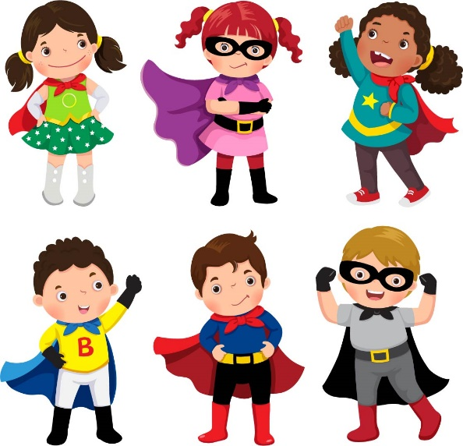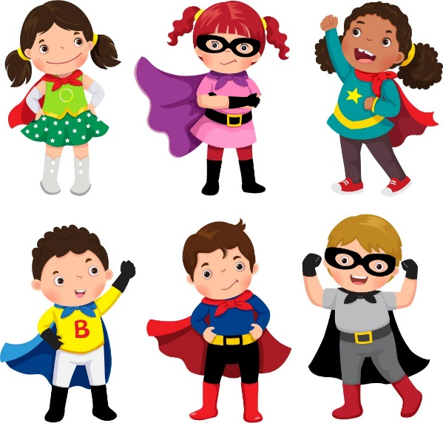

**Somos super chicos**

|  |  |
| --- | --- |
|  |  |
|  |  |
|  |  |
|  |  |
|  |  |
|  |  |
|  |  |
|  |  |
|  |  |
|  |  |
|  |  |
|  |  |

The Learning Patio-Dos Idiomas